1Check if file already existed

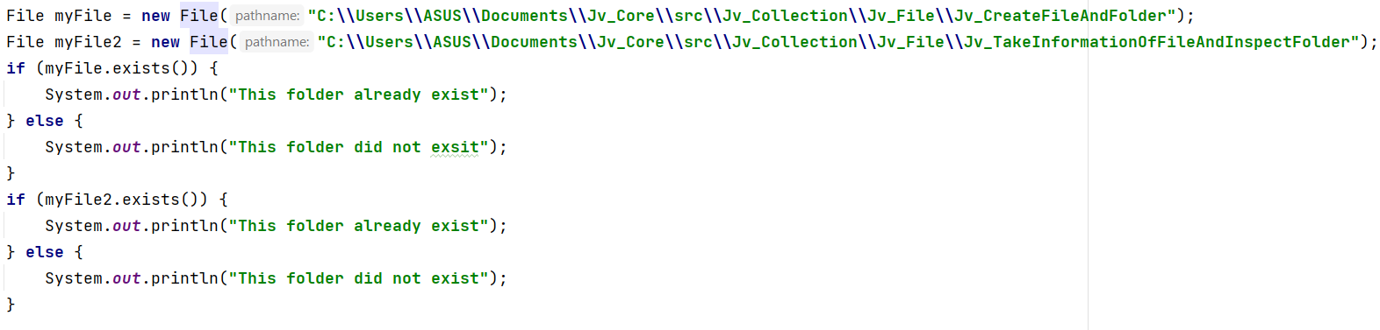

2.Create new folder



3.Create new file

